BUSINESS INTELLIGENCE
BASIC OF DATA WAREHOUSE



KHEN MUHAMMAD CAHYO
244107023002
TI-2I
STATE POLYTECHNIC OF MALANG
INFORMATION TECHNOLOGY DEPARTMENT

PRACTICUM PART 1 – Setting Up Large Database Examples
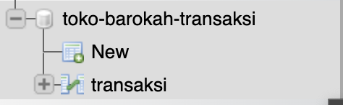
PRACTICUM PART 2 – Preparing an Application Sample
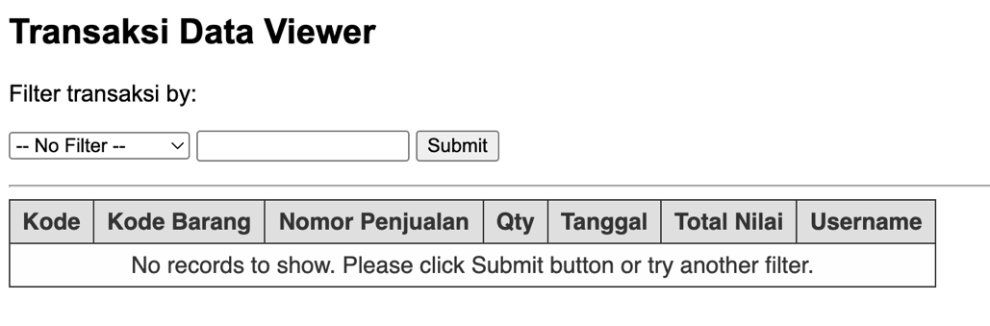
PRACTICUM PART 3 - Observing Application Performance with Large Amounts of Data
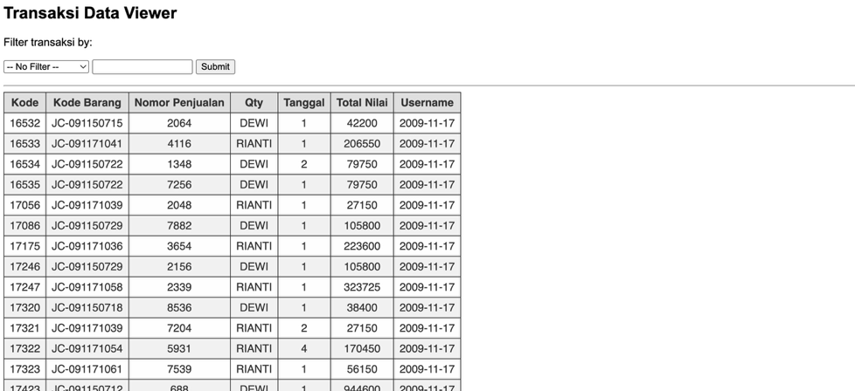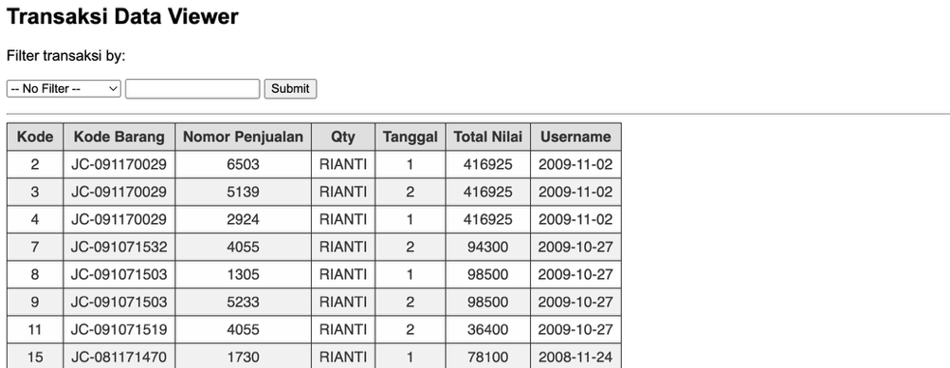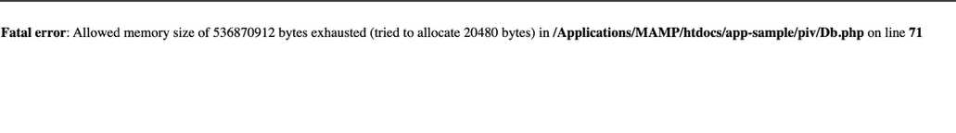

TRAINING TASK
Answer Number 1

As seen in the image above, the server took 17 minutes to respond to the client's request before the loading indicator stopped, out of a total of 443 thousand transaction data.
Answer Number 2
Here is the query for Delete all data from 2017.
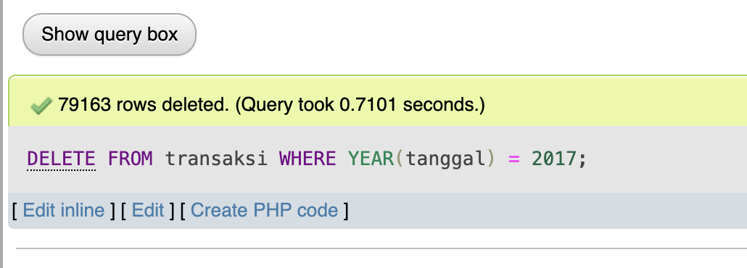
DELETE FROM transaksi WHERE YEAR(tanggal) = 2017;
Answer Number 3

The time decreased by 5 minutes from 17 minutes to 12 minutes after the data decreased by nearly 80 thousand.
Answer Number 4
In the first error, PHP failed to allocate an additional 4096 bytes (4KB) when the data had been reduced by about 80 thousand, while in the second error (Answer Number 1), PHP failed to allocate 20480 bytes (20KB) when the data was still full at almost 443 thousand. This means that it is not the raw data size that determines when an error occurs, but rather how the data is handled in memory (for example, when looping, fetching queries, or forming arrays/objects). So even though the amount of data is smaller, the memory requirements for certain processes is different.
Answer Number 5
In conclusion, when we have a large amount of data, we cannot display all of it at once, as this can cause the server to crash, preventing client requests from being processed.
Therefore, instead of displaying all the data directly, we can use several optimization techniques to prevent the server from crashing, such as pagination, data caching, etc. Additionally, to anticipate time limits when the server is executing, we can add time limits according to our needs, and we can also add memory allocation on the server to handle requests. However, basically, the time limits and memory allocation provided by each programming language are more than sufficient.

